SIMATS ENGINEERING (SAVEETHA SCHOOL OF ENGINEERING)
Department of Computer Science and Engineering

ASSESSMENT TOOL 1 – CLASS TEST (5 Questions)

Course Code: | DSA06 | Course Title: | Data Handling and Visualization
CO Assessed: | CO5 – Precision (BL6) | Assessment: | Assessment Tool 1 – Class Test
Weightage: | 40% of CIA | Total Marks: | 50 (5 Questions × 10 Marks)
CO5 Statement: | Create effective and interactive visualizations by integrating data wrangling and advanced visualization tools (BL6)
Student Name: | JANI DILIP | Reg. No.: | 192424314
Section / Batch: | B-TECH (AI & DS) | Date: | 18-08-2026

Code of Conduct
I JANI DILIP (192424314) certify that this submission is my original work and that I have adhered to the guidelines specified for this assessment. I understand that any violation of academic integrity rules will result in disciplinary action.
Signature of the Student: 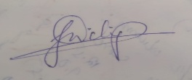
Instructions
- This test contains 5 questions, each carrying 10 marks. Total: 50 Marks.
- No negative marking. Unanswered questions carry zero marks.
- No calculators or electronic devices permitted.
- Duration: 60 minutes.
Section / Topic | Focus | Q Nos Marks
Uncertainty & Confidence Intervals | Uncertainty of point estimates, confidence intervals, trend estimation | 1 | 10
Handling Overplotting | Overlapping points, jittering, transparency | 2 | 10
Principles of Effective Visualization | Proportional ink principle, avoiding misleading axes | 3 | 10
Accessibility & Misuse of Color | Color accessibility, avoiding misuse of color | 4 | 10
Probability & Hypothetical Outcome Plots | Probability distribution and hypothetical outcome plots | 5 | 10
 | GRAND TOTAL: | 50 Marks

Annexure A – Class Test

- A survey estimates the average monthly income (₹) of two cities:
City | Mean Income | Confidence Interval
A | 25,000 | ± 2,000
B | 27,000 | ± 5,000
Represent this dataset using a suitable graph to visualize uncertainty. Justify your choice and interpret which city has more reliable estimates.

- A dataset contains exam scores of 200 students, where many students have similar scores:
Score | Frequency
50 | 30
60 | 45
70 | 60
80 | 40
90 | 25
Choose an appropriate visualization to avoid overplotting. Explain how techniques like jittering or transparency can improve clarity.

- A company reports revenue growth:
Year | Revenue (₹ lakhs)
2021 | 100
2022 | 110
2023 | 115
Create a graph that avoids misleading axes and follows the proportional ink principle. Explain how improper axis scaling could distort interpretation.

- A dataset shows profit/loss across departments:
Department | Status
HR | Profit
Sales | Loss
IT | Profit
Finance | Loss
Design a suitable visualization ensuring accessibility. Suggest color choices and explain how to avoid misuse of color for colorblind users.
- A factory produces light bulbs with a 5% defect rate. A quality control engineer wants to visualize the probability of defects in batches of 20 bulbs.
Represent the probability distribution using a suitable graph (e.g., hypothetical outcome plot or probability plot). Interpret the likelihood of observing 0, 1, or more defective bulbs.
Rubrics for Calculation

Weightag  Criteria e |  | Level 4 –  Exemplary |  | Level 3 – Proficient | Level 2 –  Developing |  | Level 1 –  Beginning | Marks
Understanding of Concepts | 25% | Demonstrates thorough, accurate understanding of concepts |  | Good understan ding with minor gaps | Basic understanding with some misconception s |  | Poor understand ing; major misconcept ions
Explanation | 25% | Detailed, wellexplained answers with relevant examples |  | Clear explanatio n with adequate details | Limited explanation; lacks depth |  | Poor or unclear explanation
Application | 20% | Effectively applies concepts with strong analytical ability |  | Applies concepts with minor errors | Limited application with weak analysis |  | No  application or incorrect analysis
Organization | 15% | Well-structured answers with logical flow and coherence |  | Organized with minor issues in flow | Basic structure, lacks clarity |  | Poor organizatio n, incoherent answers
Accuracy | 10% | Completely accurate and covers all required points |  | Mostly accurate with minor omissions | Partially correct with missing points |  | Incorrect answers with major gaps
Faculty In-charge |  |  | Course Coordinator |  |  | Head of Department
Signature: _______________ |  |  | Signature: _______________ |  |  | Signature: _______________
Date: ___________________ |  |  | Date: ___________________ |  |  | Date: ___________________

1. Visualizing Uncertainty Using an Error Bar Chart
Given Data
City | Mean Income | Confidence Interval
A | ₹25,000 | ± ₹2,000
B | ₹27,000 | ± ₹5,000
The point represents the estimated mean, while the error bar shows the range within which the actual value may lie.
Important Points
- City A mean = ₹25,000
- City A interval = ₹23,000 to ₹27,000
- City B mean = ₹27,000
- City B interval = ₹22,000 to ₹32,000
- City A has a smaller confidence interval.
- Smaller interval → less uncertainty → more reliable estimate.
Interpretation
City A has the more reliable estimate because its uncertainty is only ±₹2,000, compared with ±₹5,000 for City B.
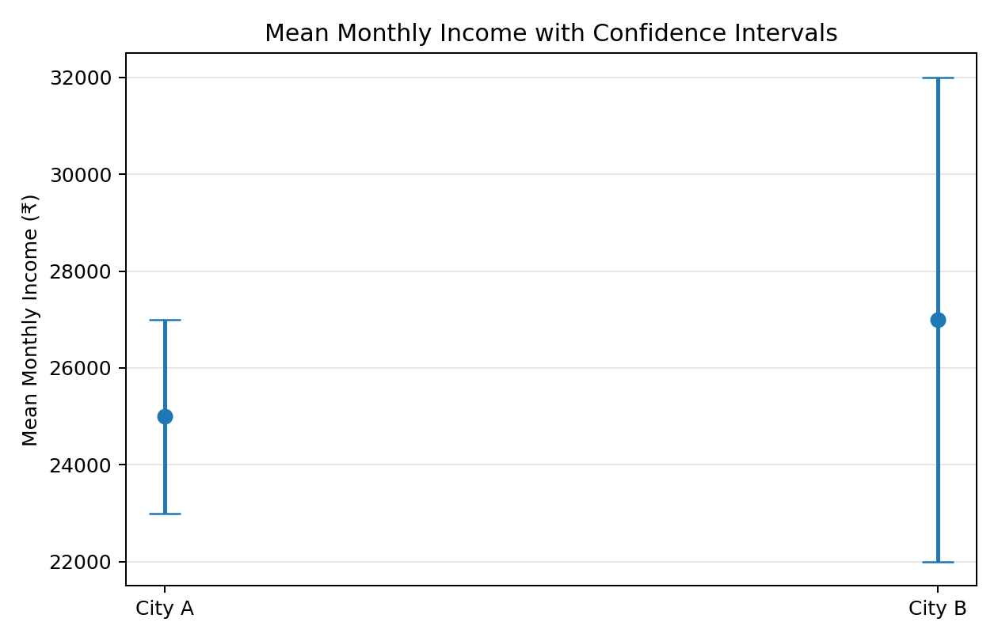
2. Visualization of Exam Scores
Given Data
Score | Frequency
50 | 30
60 | 45
70 | 60
80 | 40
90 | 25
It is suitable here because the dataset gives score values and their frequencies.
Important Points
- Score 70 has the highest frequency = 60 students.
- Score 90 has the lowest frequency = 25 students.
- The graph makes comparison between scores easy.
- A bar chart prevents the problem of overlapping points.
Overplotting
Overplotting occurs when many data points are drawn in the same location and overlap each other.
Two techniques can solve this:
Jittering
- Adds a small random displacement to points.
- Makes overlapping observations visible.
Transparency
- Makes points partially transparent.
- Areas with many overlapping points become darker.
- Helps identify data concentration.
Interpretation
The majority of students scored around 70, making 70 the most frequent score.
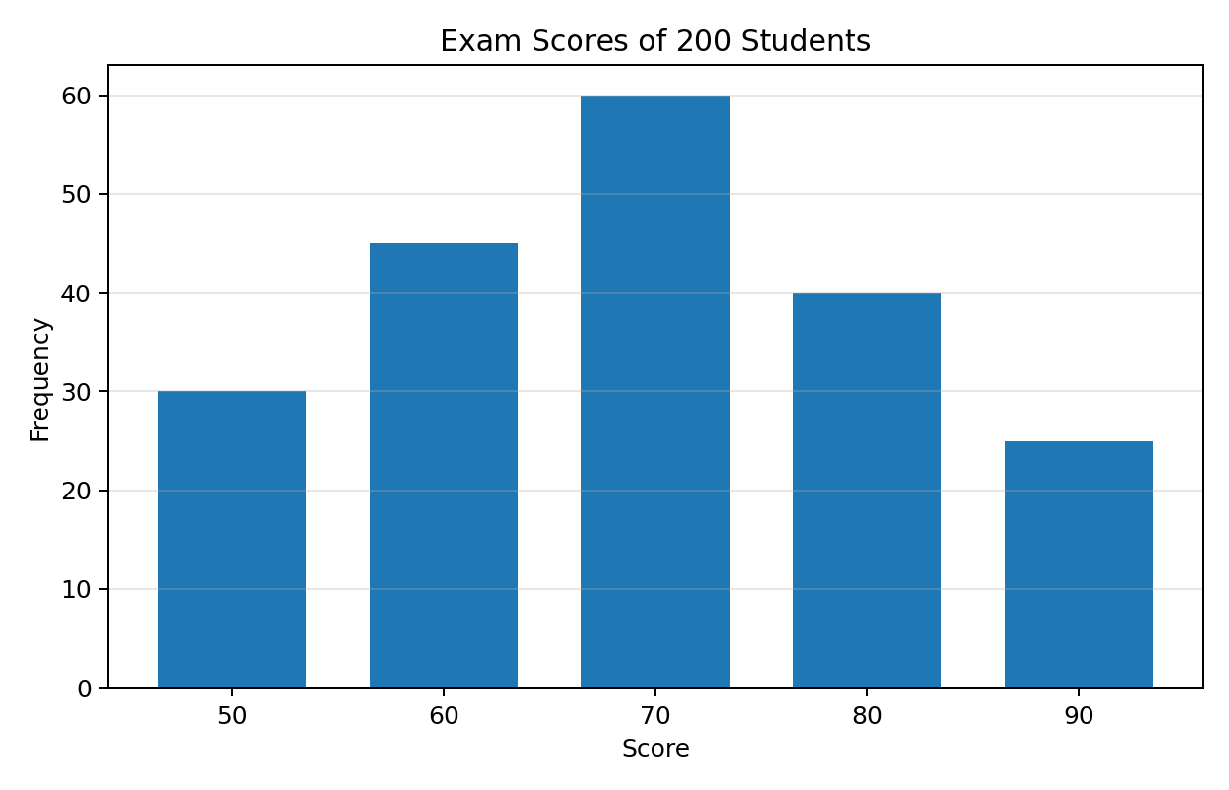

3. Revenue Growth and Proportional Ink Principle
Given Data
Year | Revenue (₹ lakhs)
2021 | 100
2022 | 110
2023 | 115
The proportional ink principle means that the visual size of a graphical element should accurately represent the magnitude of the data.
Important Points
- Revenue increased from ₹100 lakhs → ₹110 lakhs → ₹115 lakhs.
- The Y-axis should use a sensible and consistent scale.
- A zero baseline is useful when comparing magnitudes.
- Equal intervals should represent equal numerical differences.
- Avoid unnecessary 3D effects or decorative elements.
Misleading Axis
If the Y-axis starts at a very high value, such as ₹99 lakhs, the increase may visually appear much larger than it actually is.
This can mislead the viewer about the actual growth.
Interpretation
Revenue increased gradually over the three years, from ₹100 lakhs in 2021 to ₹115 lakhs in 2023.
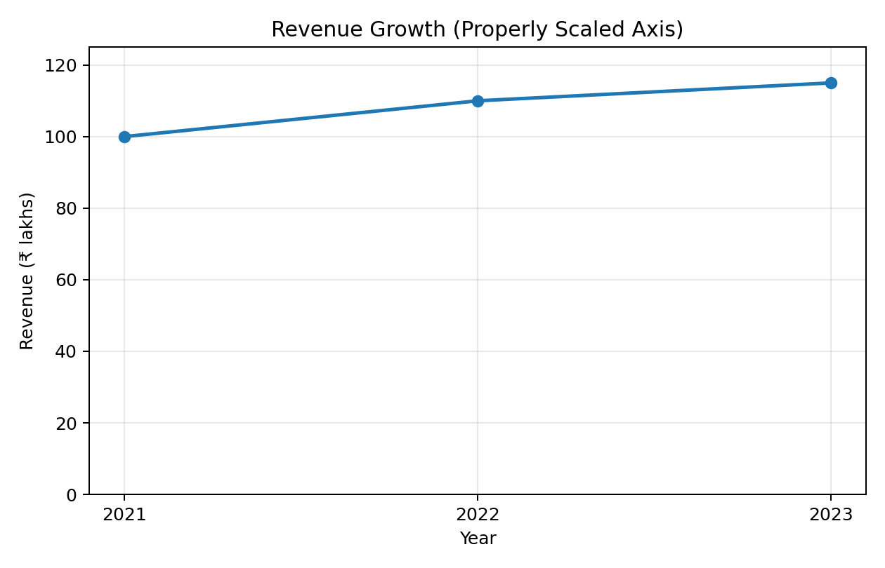

4. Visualization of Profit and Loss
Given Data
Department | Status
HR | Profit
Sales | Loss
IT | Profit
Finance | Loss
A diverging bar chart represents values on opposite sides of a central baseline.
Here:
- Positive side → Profit
- Negative side → Loss
This makes the difference between profit and loss immediately visible.
Important Points
- HR → Profit
- Sales → Loss
- IT → Profit
- Finance → Loss
- The chart uses a central zero/reference line.
- Labels should be included so that meaning does not depend only on color.
Accessibility
Charts should be designed so that they are understandable to people with color vision deficiencies.
Avoid: Using only red vs green
Better:
- Use contrasting colors such as blue and orange.
- Add Profit/Loss labels.
- Use + and − symbols.
- Use different patterns or textures when necessary.
Interpretation
HR and IT are profitable, while Sales and Finance show losses.
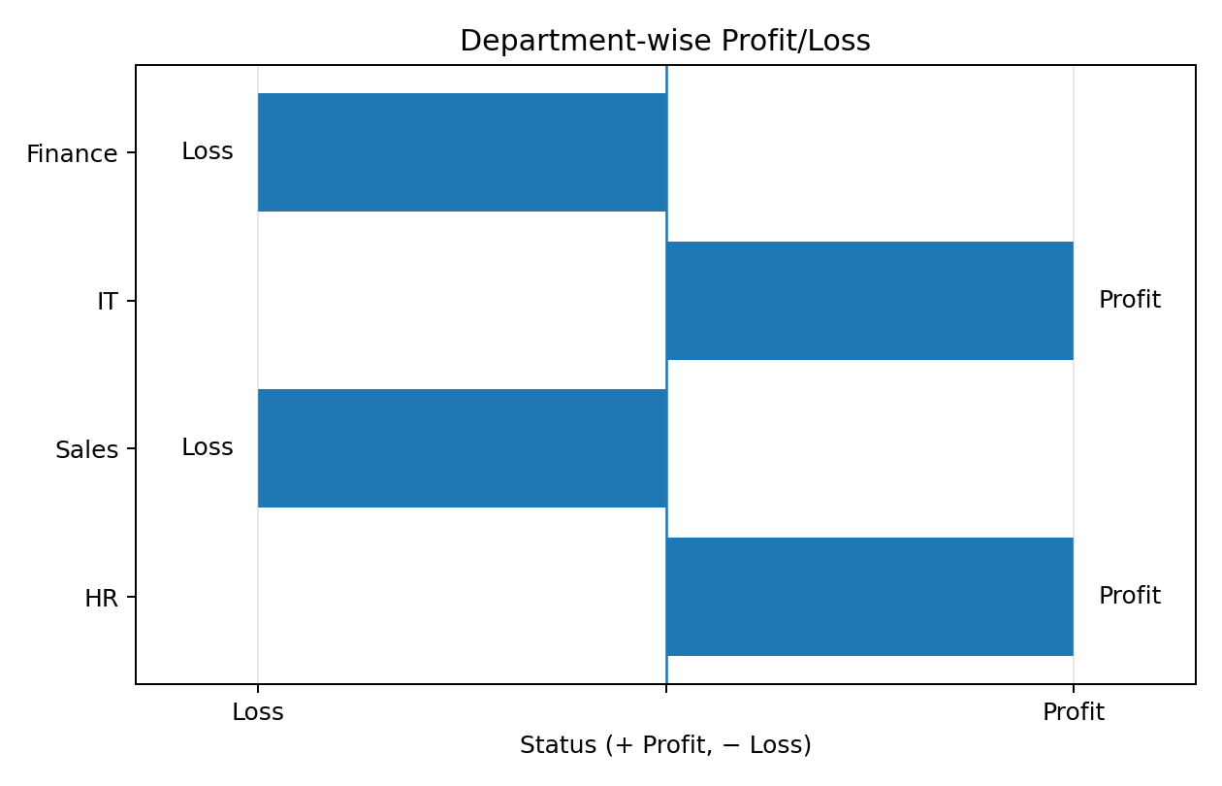
5. Probability Distribution of Defective Light Bulbs
Given
- Total bulbs = 20
- Defect probability = 5%
- Non-defect probability = 0.95
The number of defective bulbs follows a Binomial Distribution because:
- There is a fixed number of trials: 20 bulbs.
- Each bulb has two outcomes.
- Probability of defect remains approximately constant at 5%.
- Each bulb is treated as an independent trial.
Therefore,
The probability is calculated using:
Important Probabilities
Number of Defective Bulbs | Approx. Probability
0 | 35.85%
1 | 37.74%
2 | 18.86%
3 | 5.93%
4 | 1.33%
Interpretation
- 0 defective bulbs: ~35.85%
- 1 defective bulb: ~37.74% → most likely
- 2 defective bulbs: ~18.86%
- 3 defective bulbs: ~5.93%
- 4 defective bulbs: ~1.33%
The expected number of defective bulbs is:
Therefore, the factory can expect approximately 1 defective bulb per batch of 20 bulbs.

Final Conclusion
A binomial probability bar chart is appropriate because it clearly shows the probability of getting different numbers of defective bulbs. The most likely result is 1 defective bulb. 